######### Implement MLE for parameter beta

beta=seq(0.01,5,by=0.01) ### parameter values

l=length(beta)

S=9000

I=9

n=1000

logl=c()

for(i in 1:l)

{

logl[i]=n*log(beta[i]*S*I)

}

m=max(logl)

ind=which(logl==m)

mle=beta[ind]

mle

plot(beta,logl,type="l",col="blue",xlab="beta_values",ylab="logl",main="MLE for parameter beta")

abline(v=mle,col="red")

abline(h=m,col="green")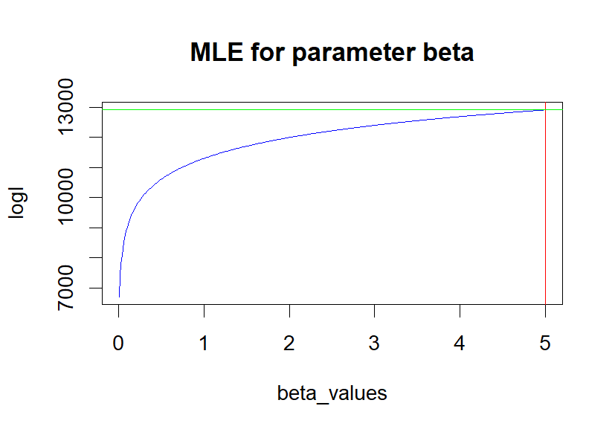

#### Result : Estimated Beta parameter values is : 5

################# Implement MLE for parameter gamma

gama=seq(-5,5,by=0.01) ### parameter values

l=length(gama)

S=9000

I=9

n=1000

beta=5

logl=c()

for(i in 1:l)

{

logl[i]=n*log(beta*S*I-(gama[i]*I))

}

m=max(logl)

ind=which(logl==m)

mle=gama[ind]

mle

plot(gama,logl,type="l",col="blue",xlab="gama_values",ylab="logl",main="MLE for parameter gama")

abline(v=mle,col="red")

abline(h=m,col="green")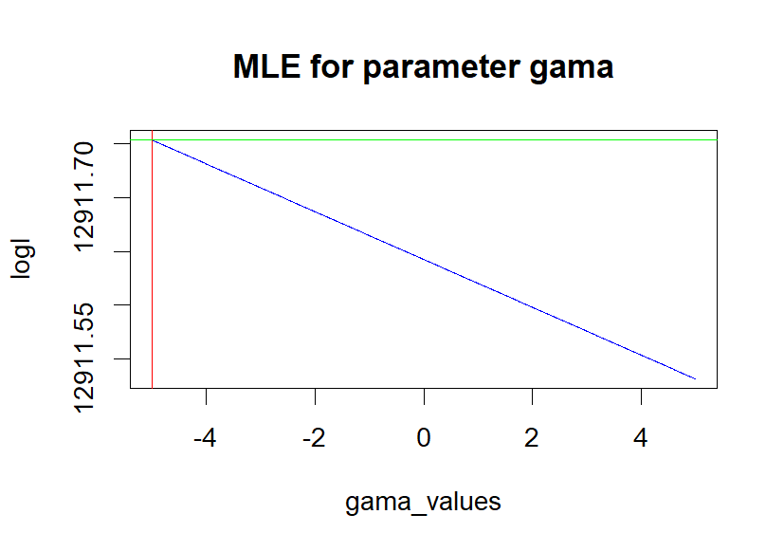

## Result : Estimated gama parameter values is : -5